

**Department of Computer Science**

**American International University-Bangladesh**

**Mid Term Assignment**



**Course Name: Database**

**Section : F**

**Department : Computer Science & Engineering**

**Prepared & submitted by:**

|  |  |  |
| --- | --- | --- |
| **NAME** | **ID** | **CONTRIBUTION** |
| MD.SHARIAR MAHMUD SACHCHA | 20-43772-2 | 20% |
| SUMAYEA KHATUN | 20-43837-2 | 20% |
| SAIMA SADIA RATRI | 20-43793-2 | 20% |
| SAYEEM BIN EZAZ | 20-43770-2 | 20% |
| MD. PEYAL SARKAR | 20-43357-2 | 20% |

**Submitted To:**

|  |
| --- |
| **COURSE TEACHER:** RIFAT TASNIM ANANNYA  LECTURER, AIUB |

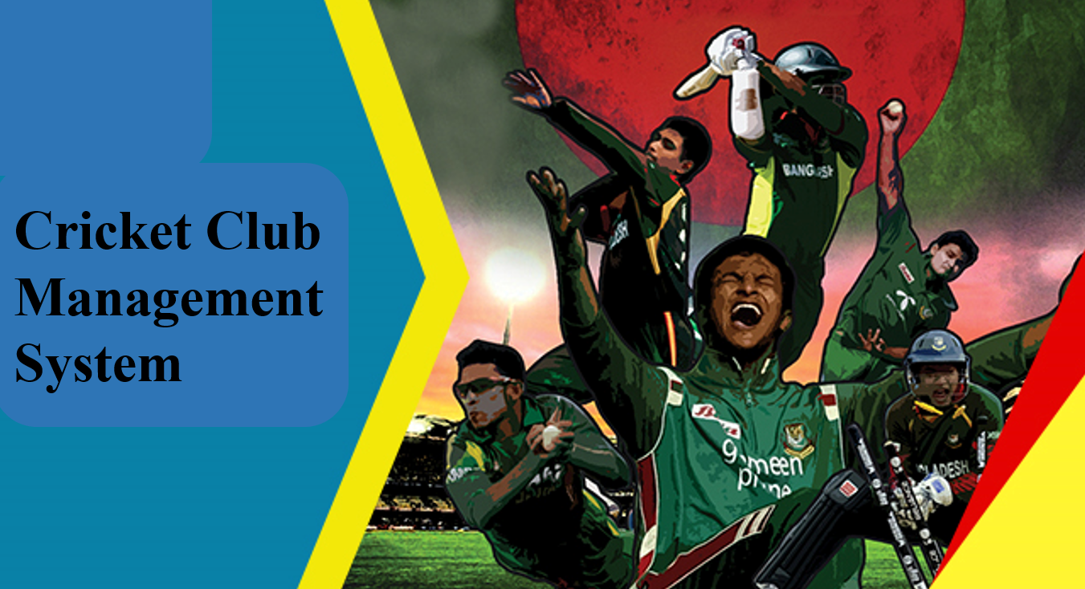

**CASE STUDY**

In a cricket club management system, there are many players, and they have many matches. Each players have its own identification. The system stores information of the players, that is ID, age, city, country, and their name. The match also has its number, type, time. One coach can teach all, but all players will have one coach. The system stores coach’s id and name and skill. There will be one physician who trains the players. One club will have one physician and he have name, ID, Phone number and his experience stored in the system. There is a doctor in the system. The doctor’s information such as name ID, phone number and skill is stored in the system. There is player history, where the players total match, total run, total wicket, and membership id will be recorded. There are a club. The system stores club name and club id. The club will organize matches. The system stores match type, match no and time. There are some equipment’s of cricket which has its code, name, type. 

**ER DIAGRAM**

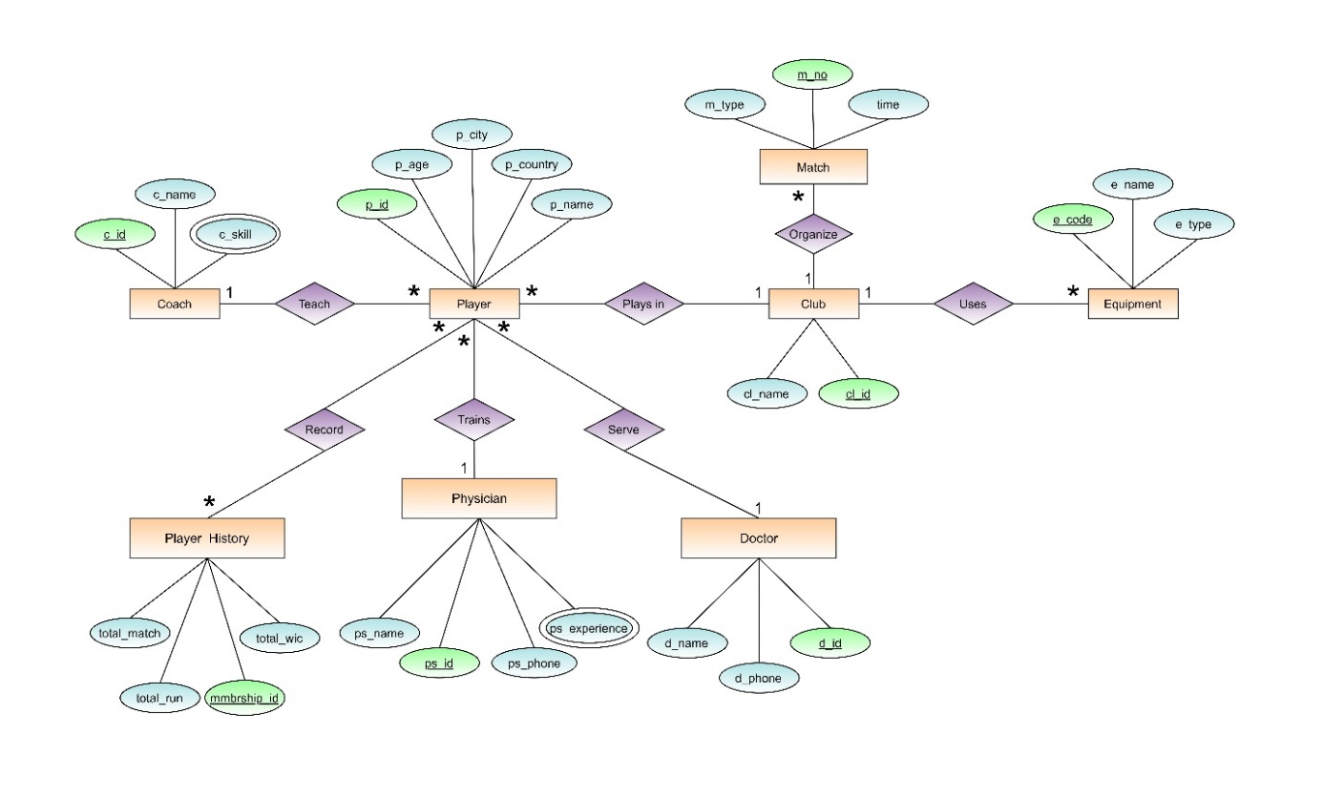

**NORMALIZATION**

**Teach-(p_id,p_age,p_city,p_country,p_name,c_id,c_name,c_skill)**

**1NF: c_skill is multivalued attribute**

**2NF: p_id,p_age,p_city,p_country,p_name**

**c_id,c_name,c_skill**

**3NF: p_id,p_age, p_name**

**a_id,p_city,p_country**

**c_id,c_name,c_skill**

**Final list from Teach-**

1. **p_id,p_age,p_name,a_id,c_id**
2. **a_id,p_city,p_country**
3. **c_id,c_name**
4. **c_id,c_skill -> composite pk**

**Record- (p_id,p_age,p_city,p_country,p_name,mmbrship_id,total_match,total_run,total_wic)**

**1NF: No multivalued attribute**

**2NF: p_id,p_age,p_city,p_country,p_name**

**mmbrship_id,total_match,total_run, total_wic**

**3NF: p_id,p_age, p_name**

**a_id,p_city,p_country**

**mmbrship_id,total_match,total_run, total_wic**

**Final list for Record-**

1. **p_id,p_age,p_name, a_id**
2. **a_id,p_city,p_country**
3. **mmbrship_id,total_match,total_run, total_wic**
4. **n_id, p_id, mmbership_id**

**Trains-(p_id,p_age,p_city,p_country,p_name, ps_id,ps_name,ps_phone,ps_experience)**

**1NF: ps_experience is multivalued attribute**

**2NF: p_id,p_age,p_city,p_country,p_name**

**ps_id,ps_name,ps_phone,ps_experience**

**3NF: p_id,p_age, p_name**

**a_id,p_city,p_country**

**ps_id,ps_name,ps_phone,ps_experience**

**Final list for Trains-**

1. **p_id,p_age,p_name, a_id, ps_id**
2. **a_id,p_city,p_country**
3. **ps_id,ps_name,ps_phone,**
4. **ps_id,ps_experience -> composite pk**

**Serve- (p_id,p_age,p_city,p_country,p_name, d_id,d_name,ps_phone_no)**

**1NF: No multivalued attribute**

**2NF: p_id,p_age,p_city,p_country,p_name**

**d_id,d_name,ps_phone_no**

**3NF: p_id,p_age,p_name**

**a_id,p_city,p_country**

**d_id,d_name,ps_phone_no**

**Final list for Serve-**

1. **p_id,p_age, p_name, a_id, d_id**
2. **a_id,p_city,p_country**
3. **d_id,d_name,d_phone**

**Plays in--(p_id,p_age,p_city,p_country,p_name, cl_id,cl_name)**

**1NF: No multivalued attribute**

**2NF: p_id,p_age,p_city,p_country,p_name**

**cl_id,cl_name**

**3NF: p_id,p_age,p_name**

**a_id,p_city,p_country**

**cl_id,cl_name**

**Final list for Serve-**

1. **p_id,p_age, p_name, a_id, cl_id**
2. **a_id,p_city,p_country**
3. **cl_id,cl_name**

**Organize-(m_no,m_type,time,cl_id,cl_name)**

**1NF: No multivalued attribute**

**2NF: m_no,m_type,time**

**cl_id,cl_name**

**3NF: m_no,m_type,time**

**cl_id,cl_name**

**Final list for Organize-**

1. **m_no,m_type,time,cl_id**
2. **cl_id,cl_name**

**Uses-(e_code,e_name,e_type,cl_id,cl_name)**

**1NF: No multivalued attribute**

**2NF: e_code,e_name,e_type**

**cl_id,cl_name**

**3NF: e_code,e_name,e_type**

**cl_id,cl_name**

**Final list for Uses-**

1. **e_code,e_name,e_type,cl_id**
2. **cl_id,cl_name**

**Final list from normalization**

1. **p_id,p_age,p_name,a_id,c_id, ps_id, d_id, cl_id -> player**
2. **a_id,p_city,p_country -> location**
3. **c_id,c_name -> Coach**
4. **c_id,c_skill -> composite pk -> Qualification**
5. **mmbrship_id,total_match,total_run, total_wic -> Player_Details**
6. **n_id, p_id, mmbership_id -> Player_Identity**
7. **ps_id,ps_name,ps_phone -> Physician**
8. **ps_id,ps_experience -> composite pk -> p_quality**
9. **d_id,d_name,d_phone -> Doctor**
10. **cl_id,cl_name -> Club**
11. **m_no,m_type,time,cl_id -> Match**
12. **e_no,e_name,e_type,cl_id -> Equipment**

**TABLE CREATE**

**Table Name: Coach**

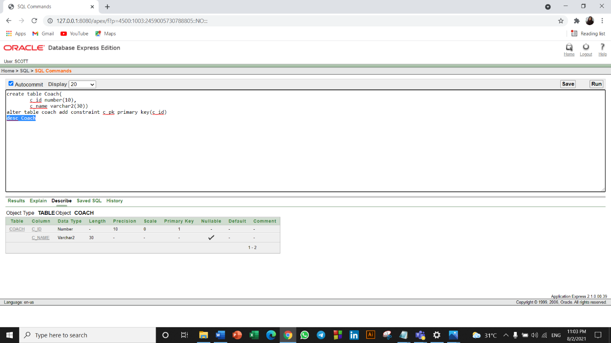

**Table Name: Physician**

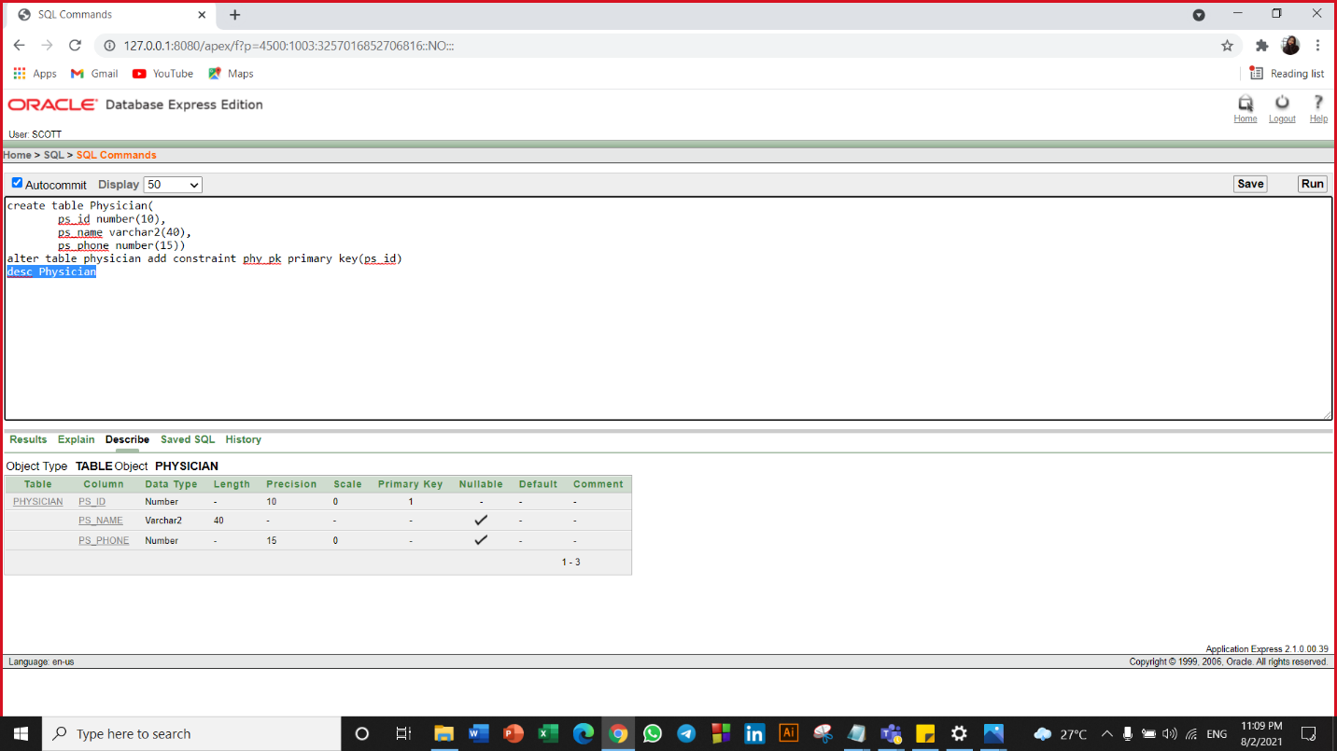

**Table Name: Location**

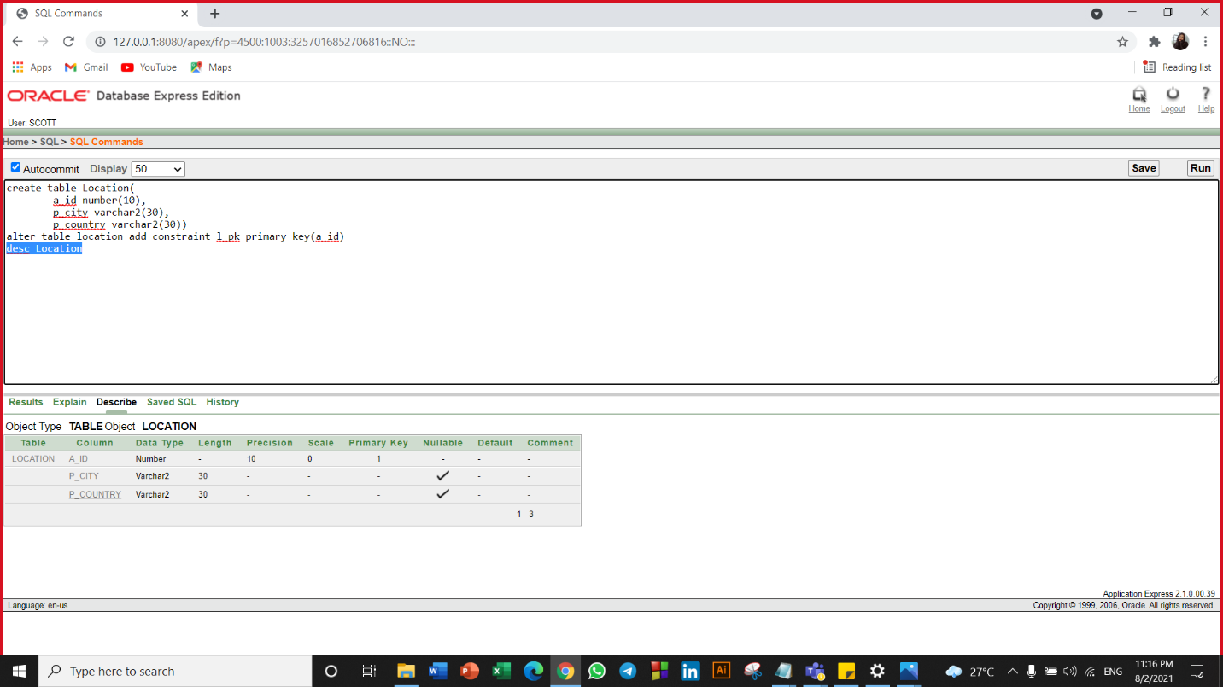

**Table Name: Doctor**

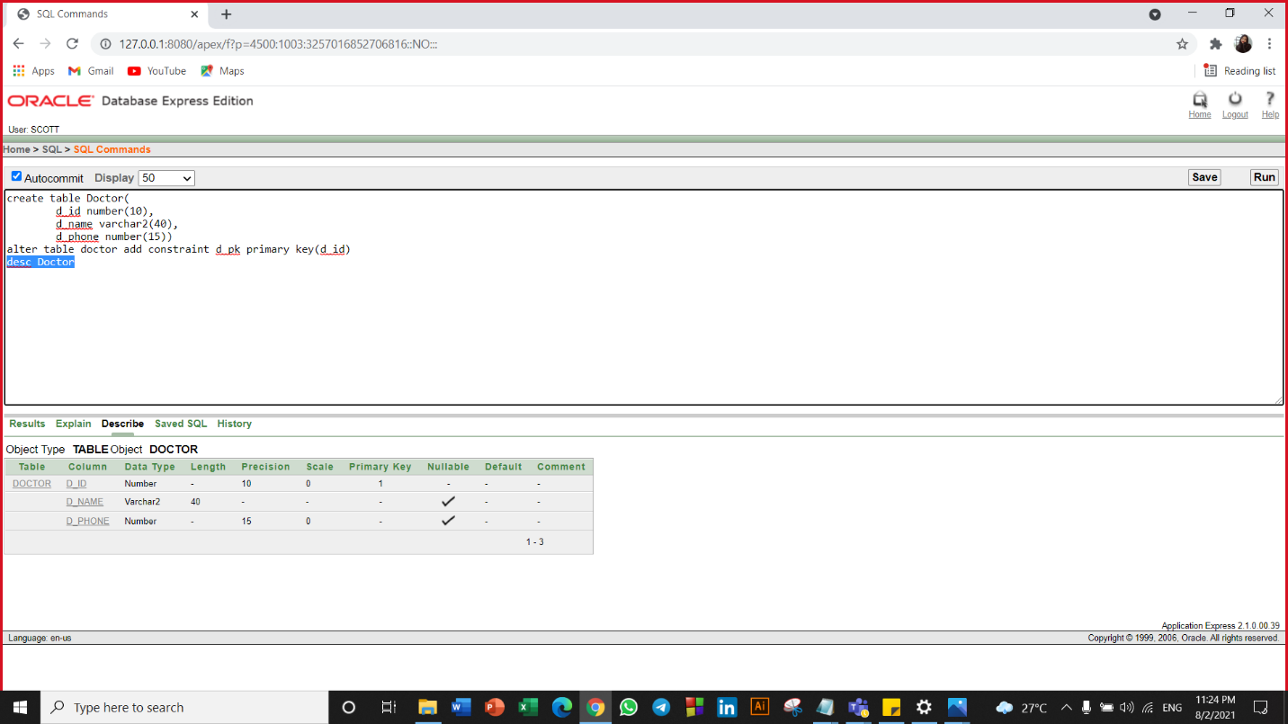

**Table Name: Club**

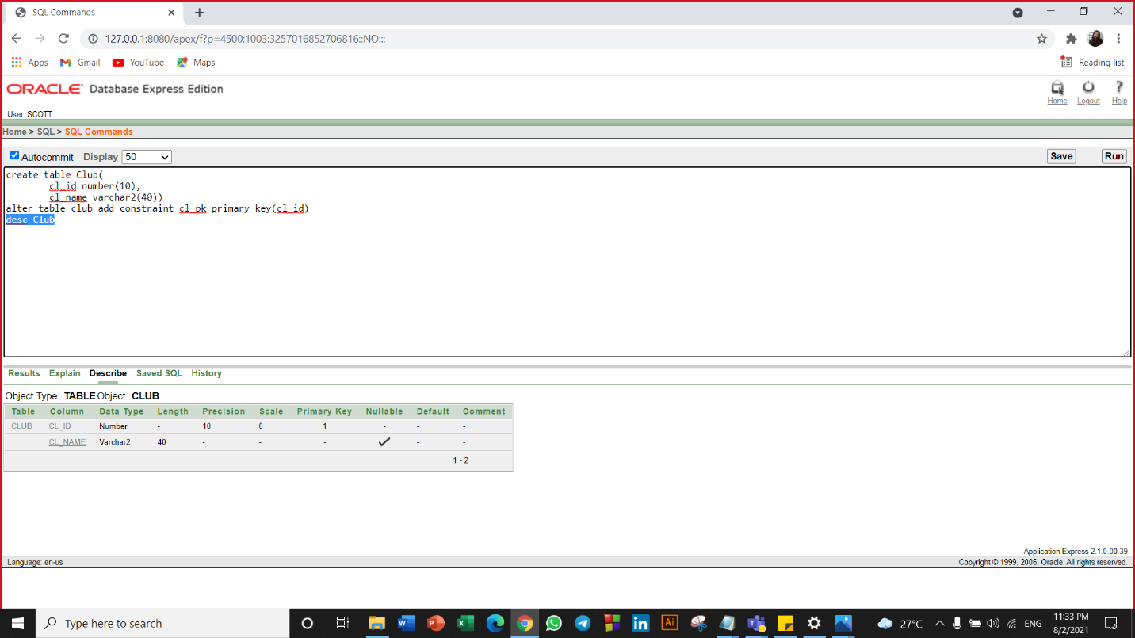

**Table Name: Player**

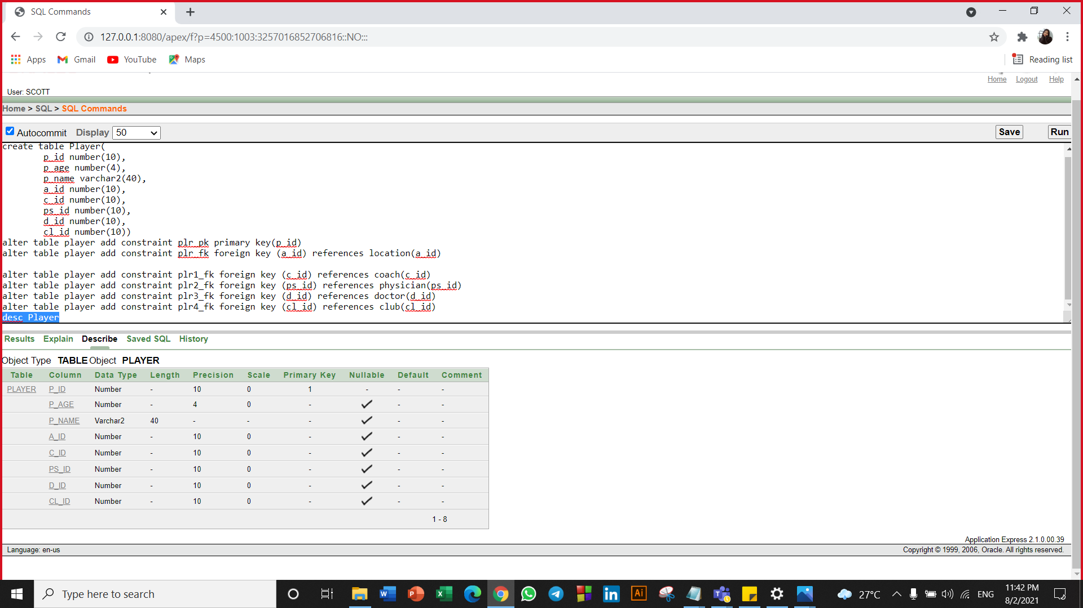

**Table Name: Player_details**

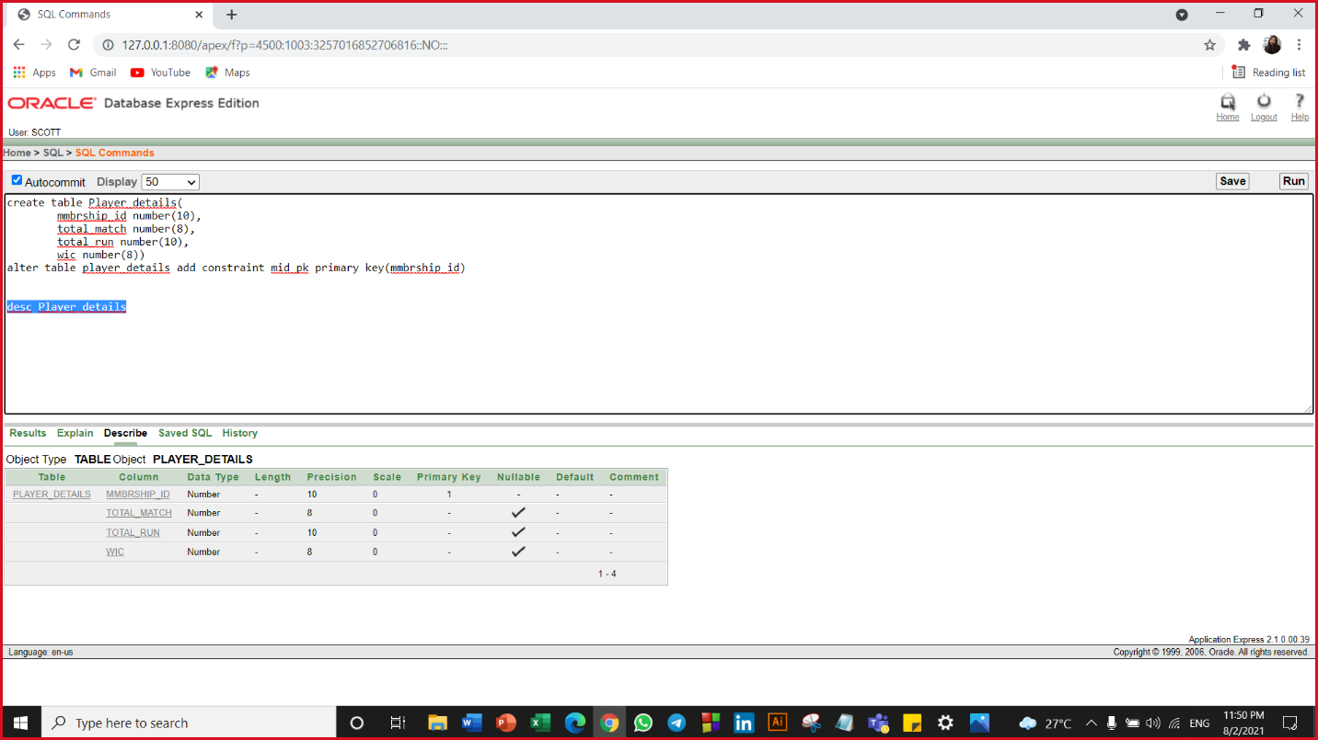

**Table Name: Player_identity**

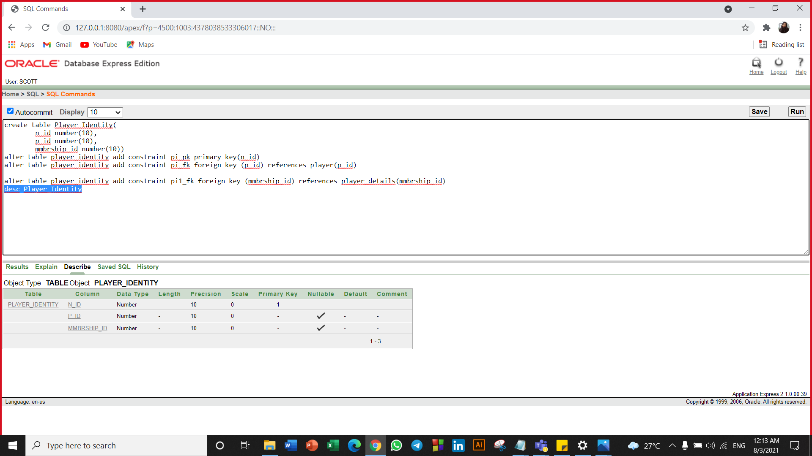

**Table Name: Match**

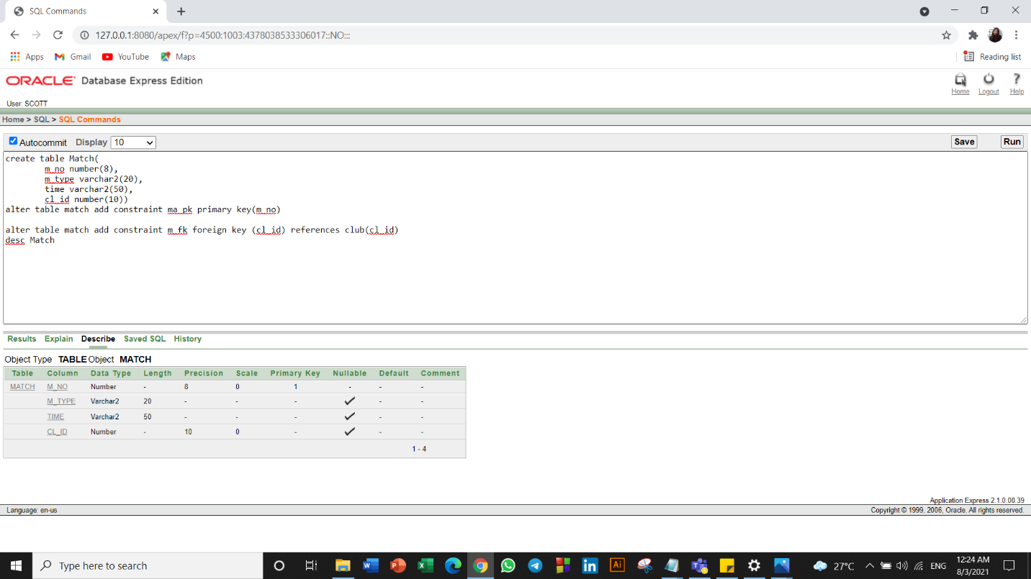

**Table Name: Equipment**

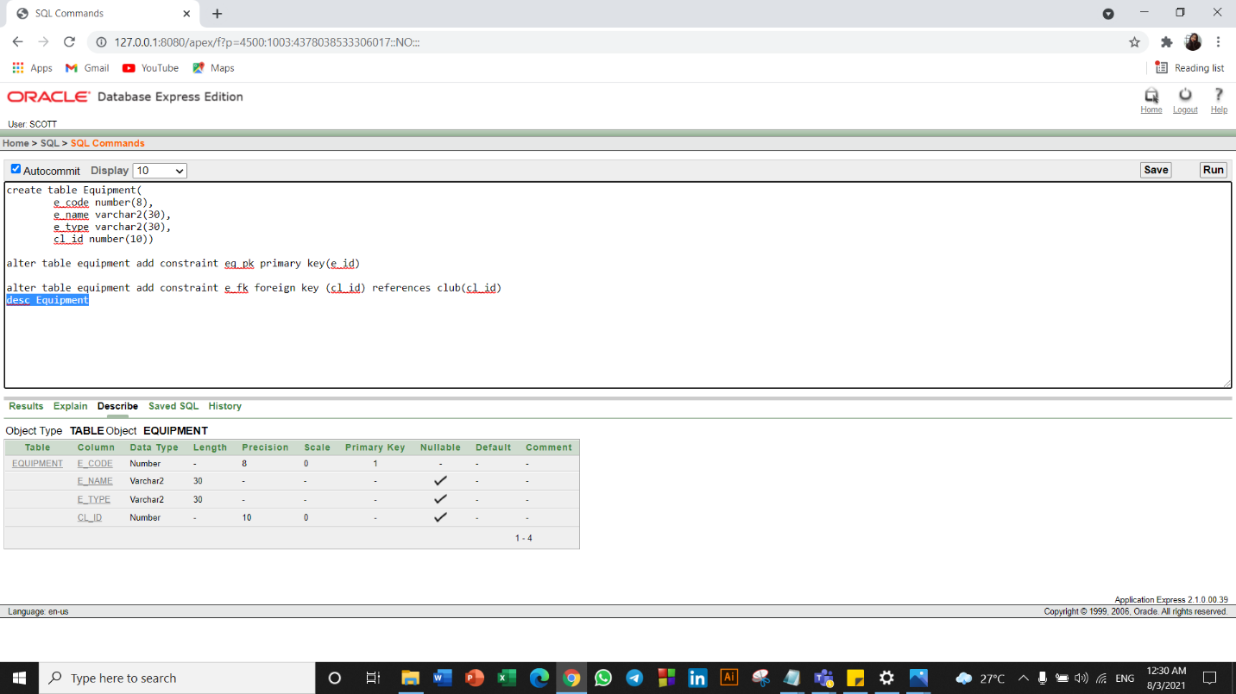

**Table Name: Qualification**

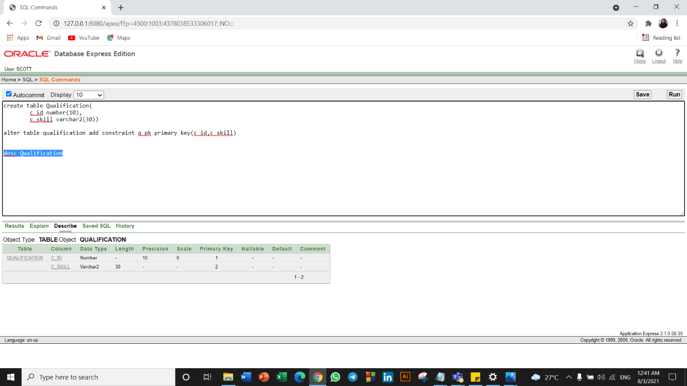

**Table Name: P_Quality**

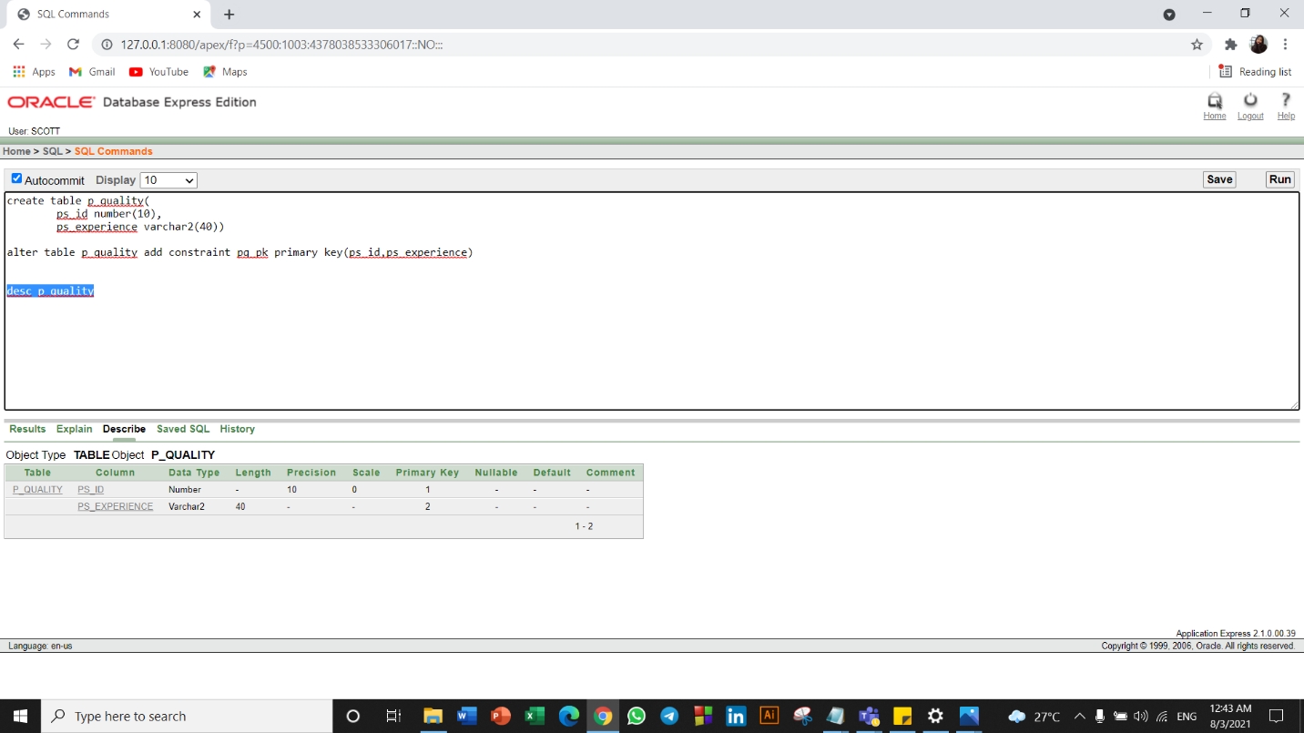

**SEQUENCES**

**Sequence has been created in equipment table**

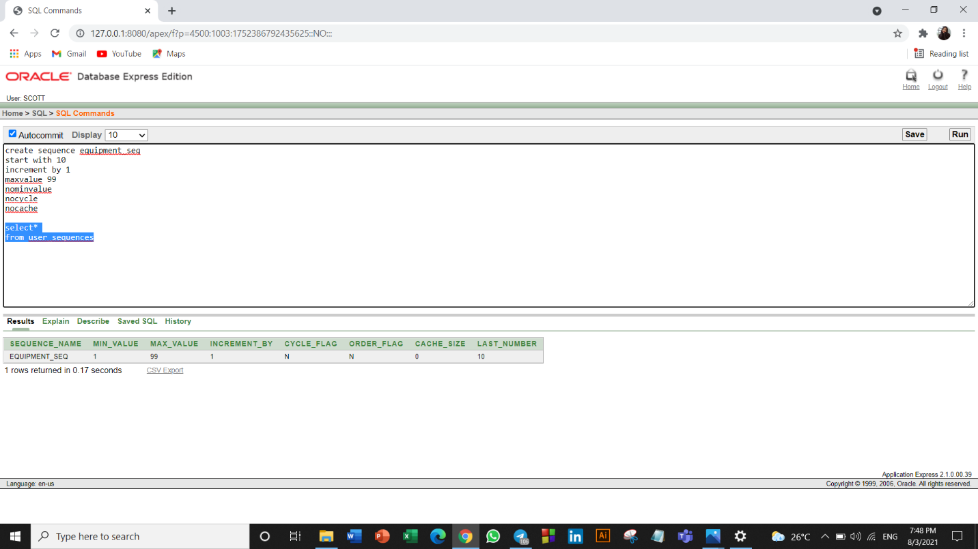

**INSERTATION**

**Table name: Coach**

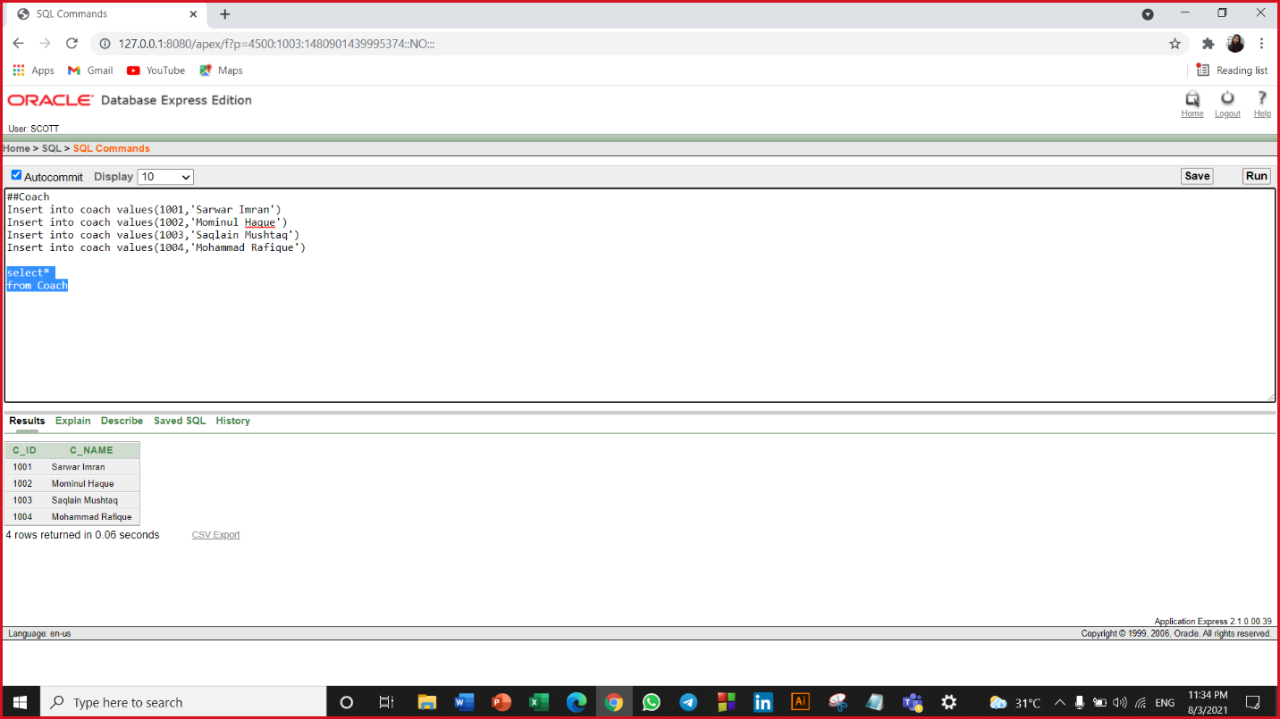

**Table Name: Physician**

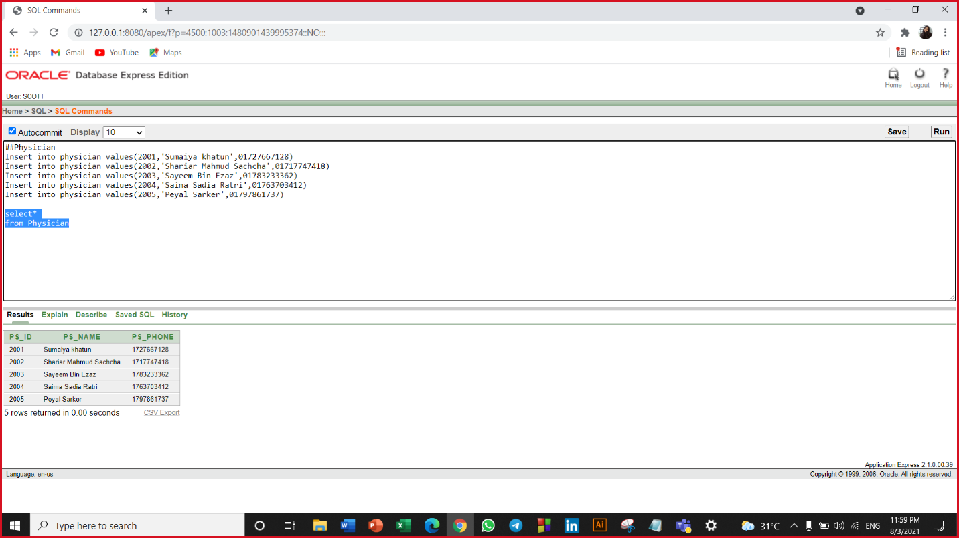

**Table Name: Location**

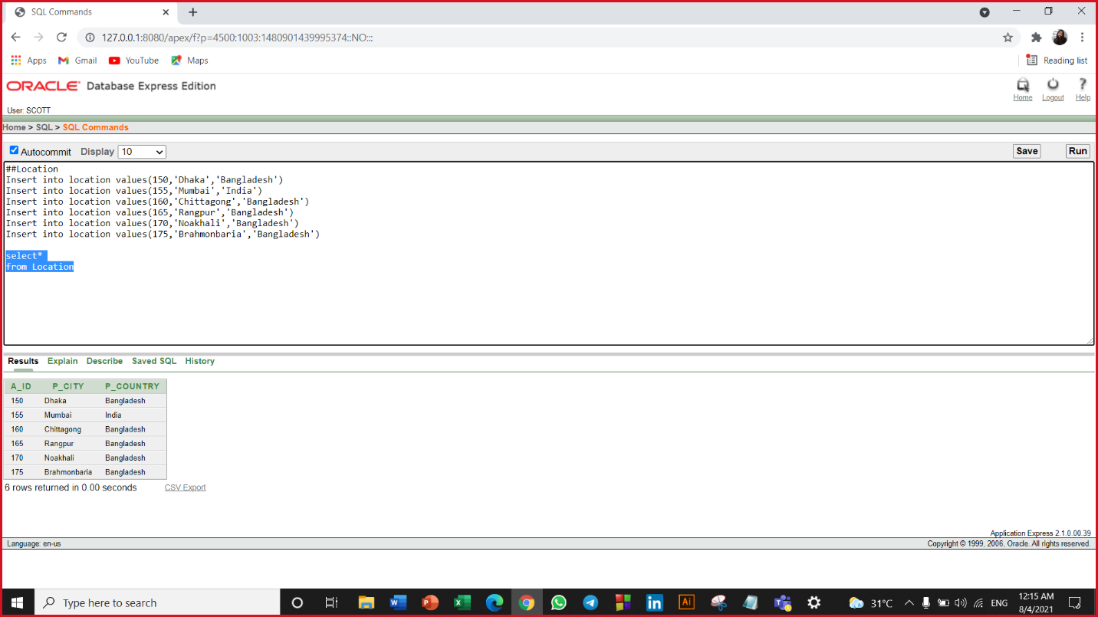

**Table Name: Doctor**

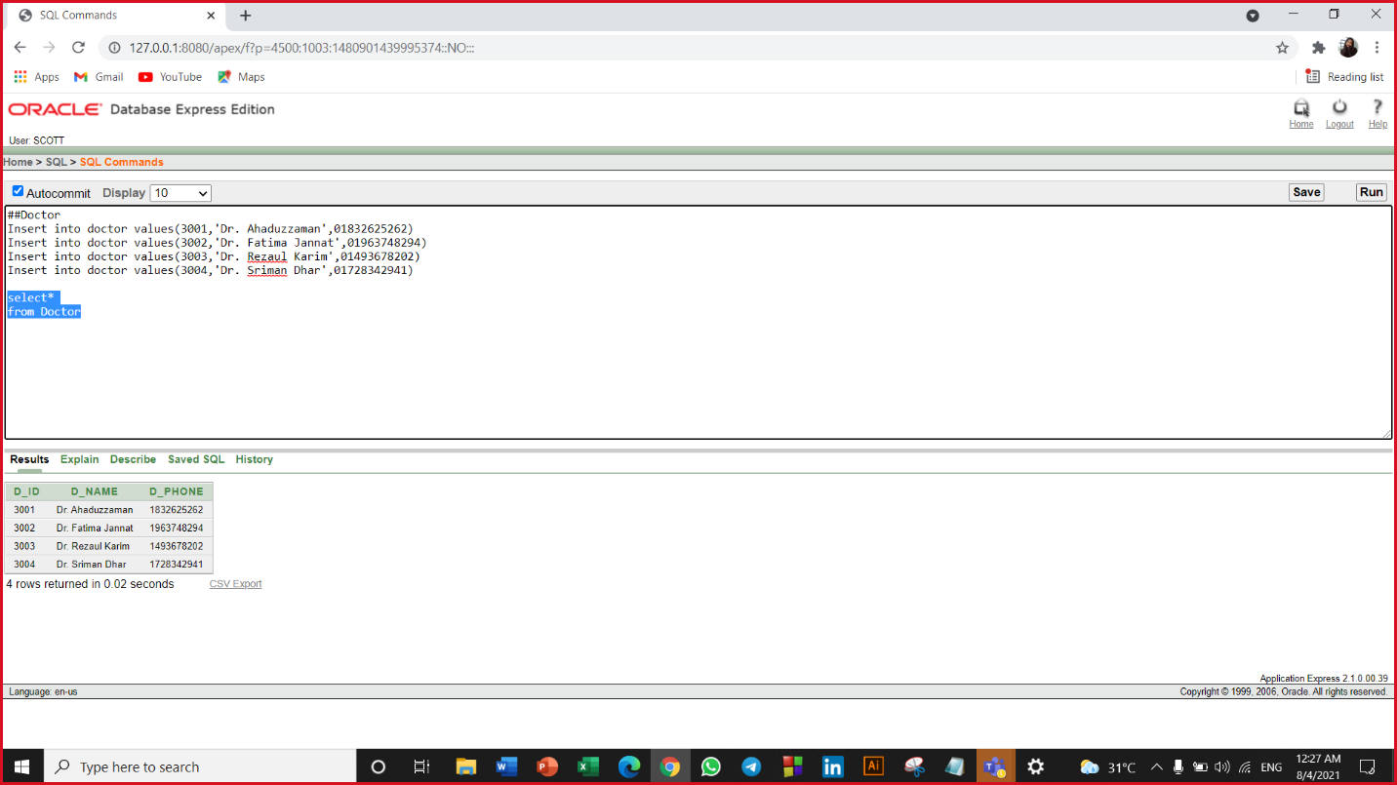

**Table Name: Club**

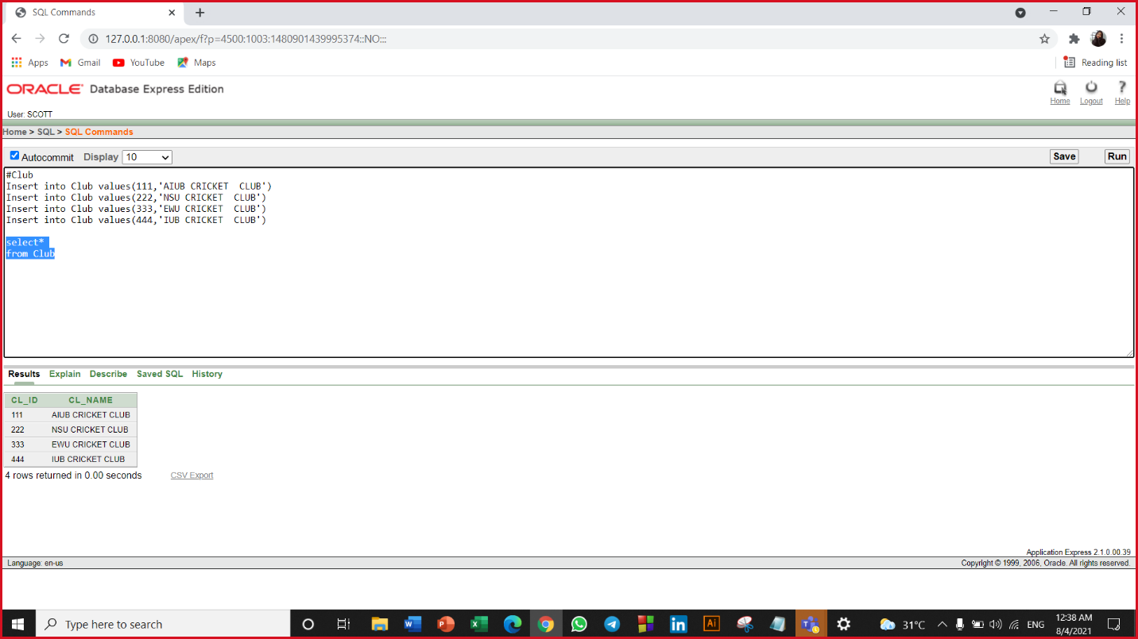

**Table Name: Player**

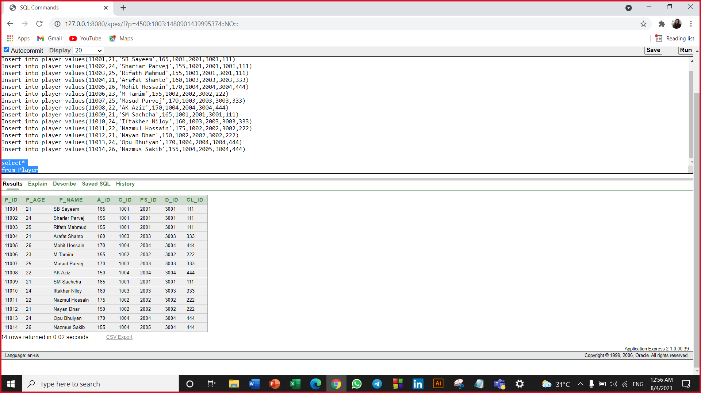

**Table Name: Player details**

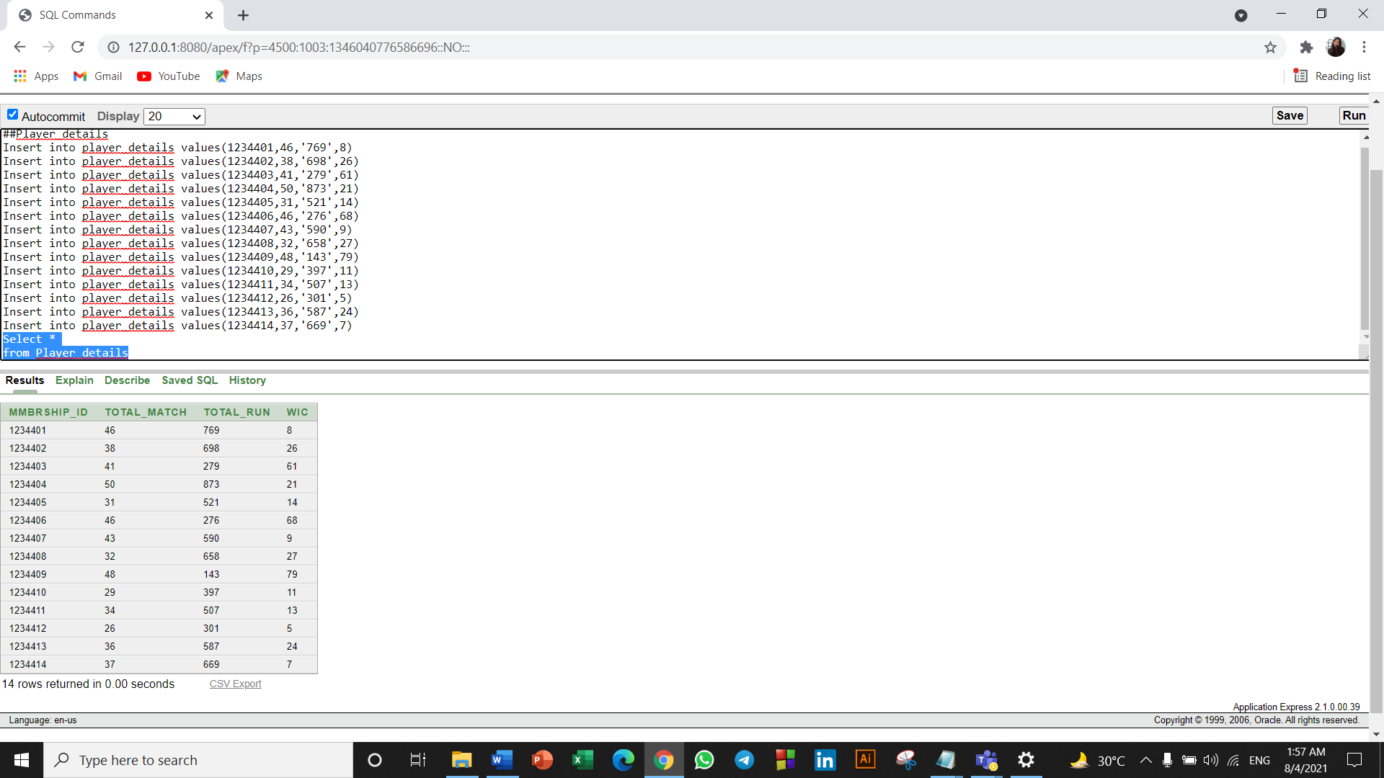

**Table Name: Player_Identity**

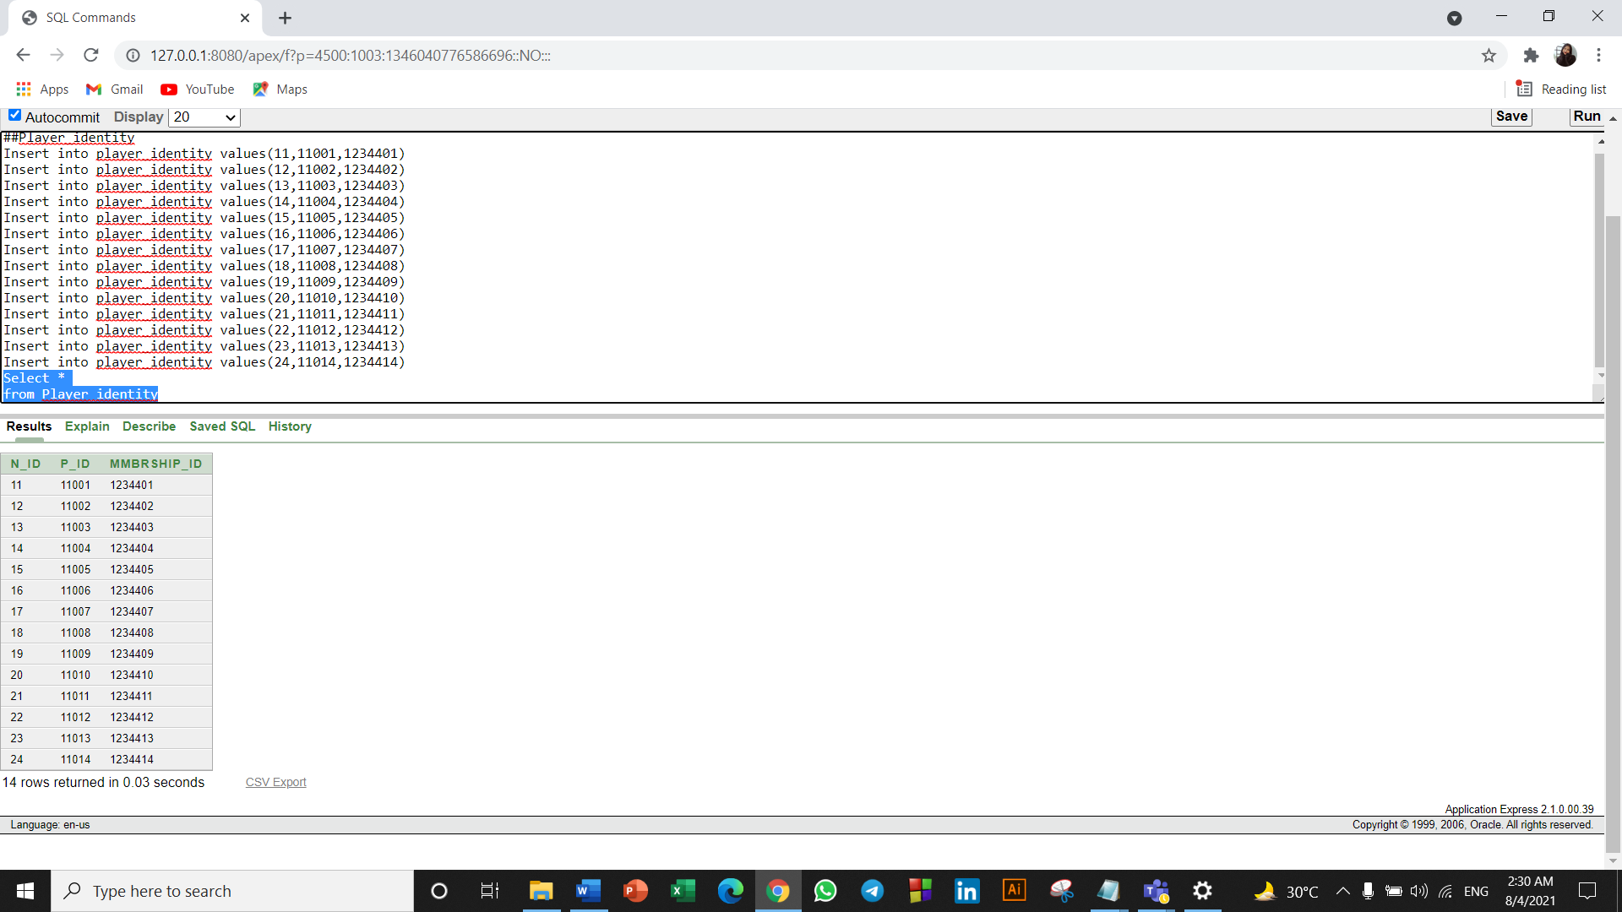

**Table Name: Match**

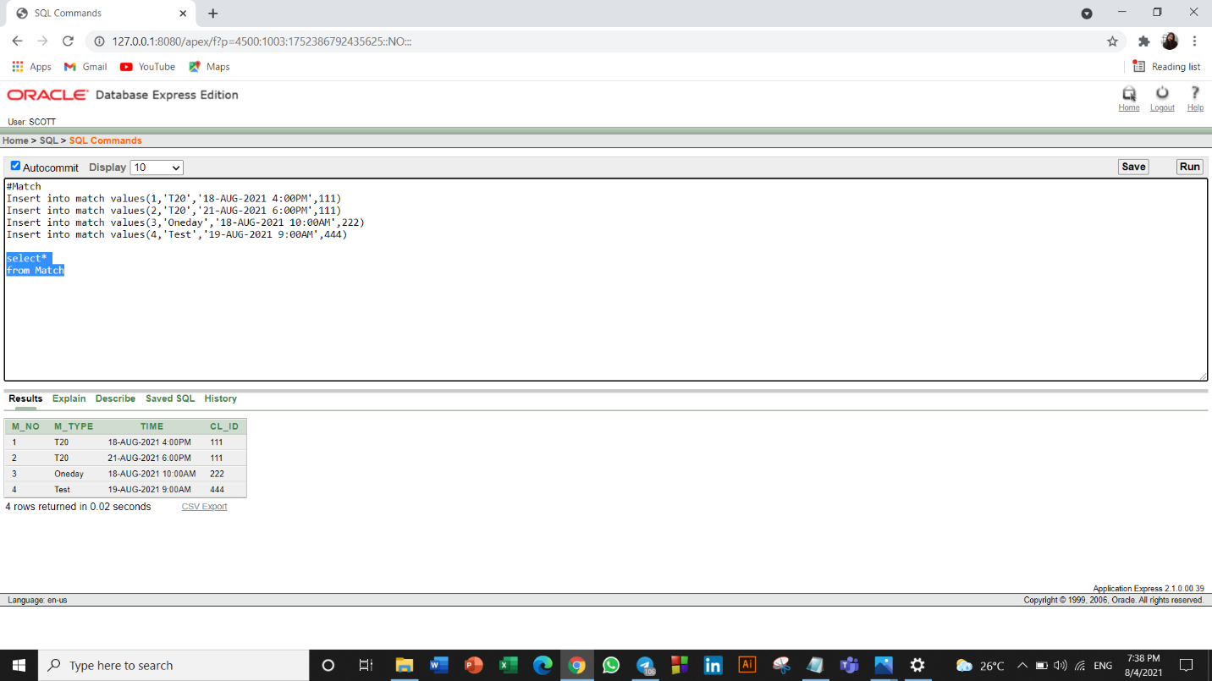

**Table Name: Equipment**

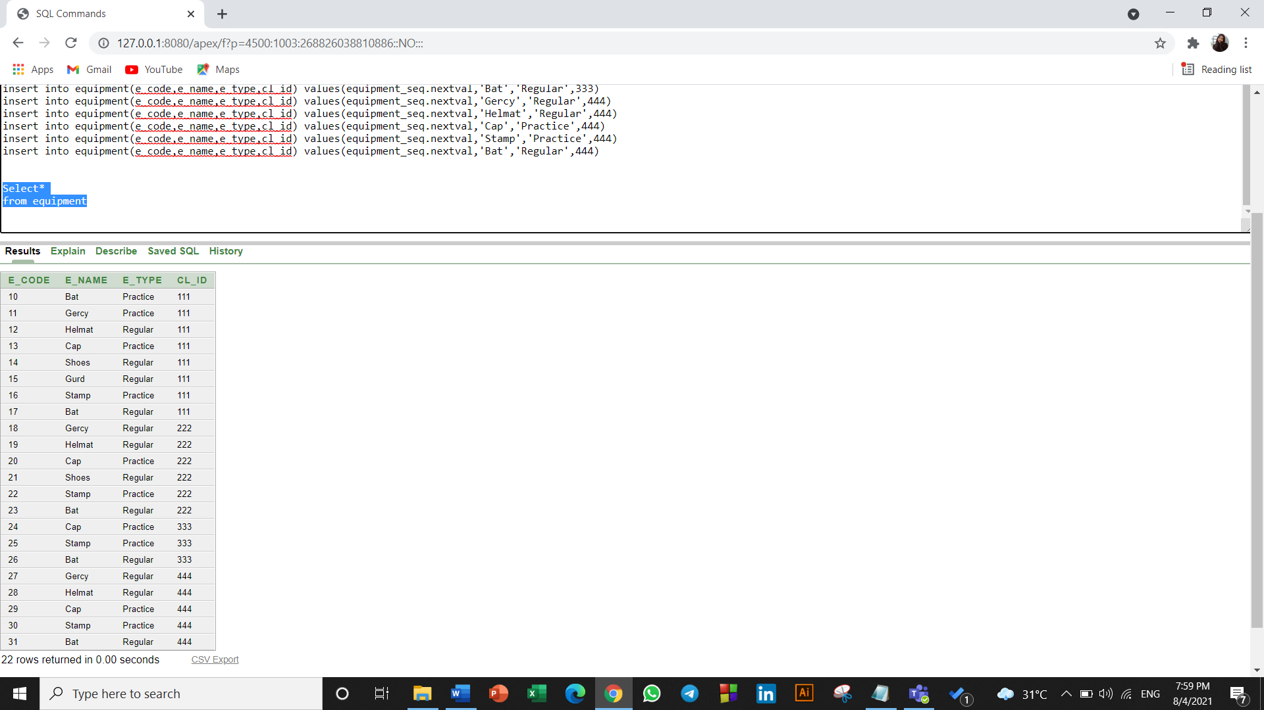

**Table Name: Qualification**

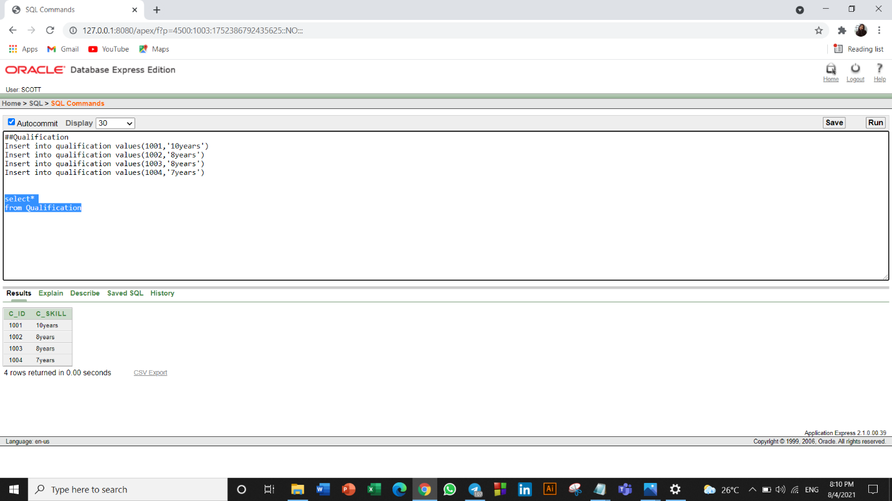

**Table Name: P_Quality**

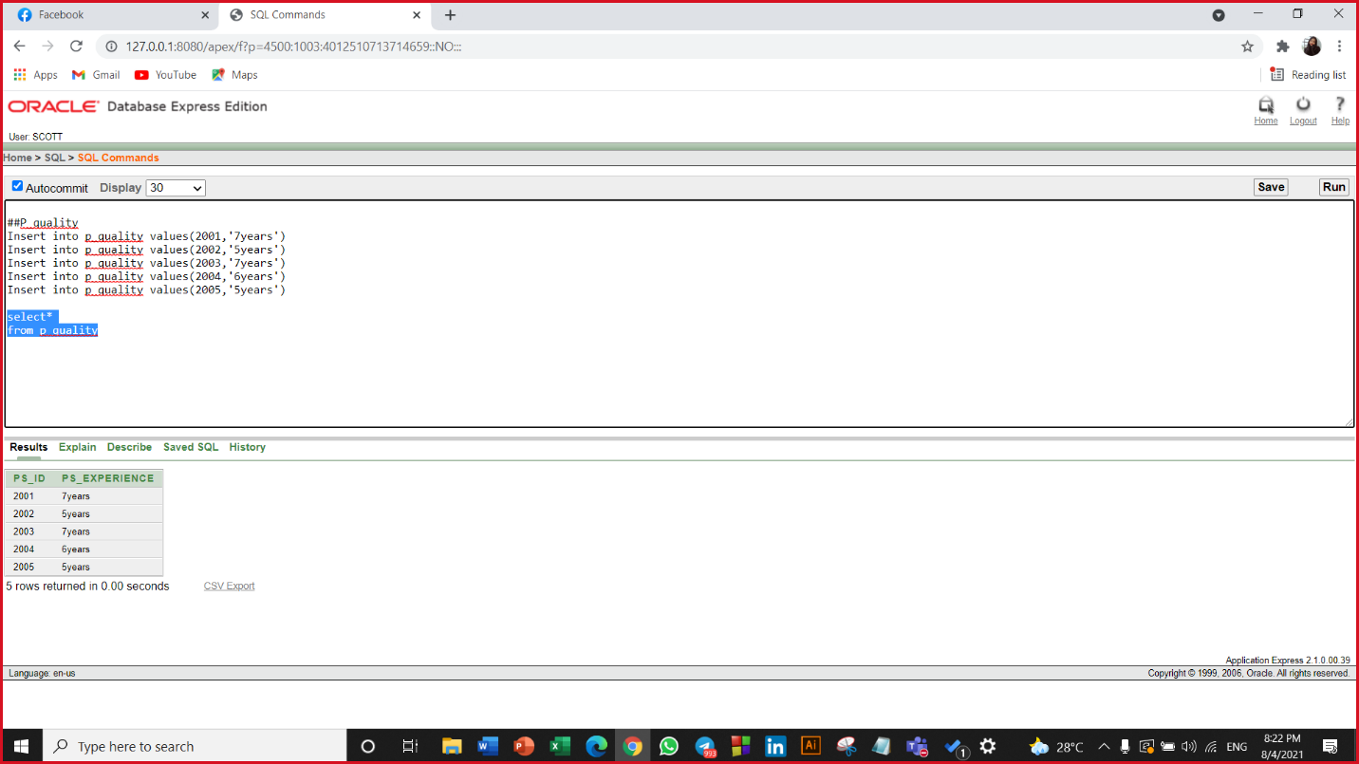

**CONSTRAINT**

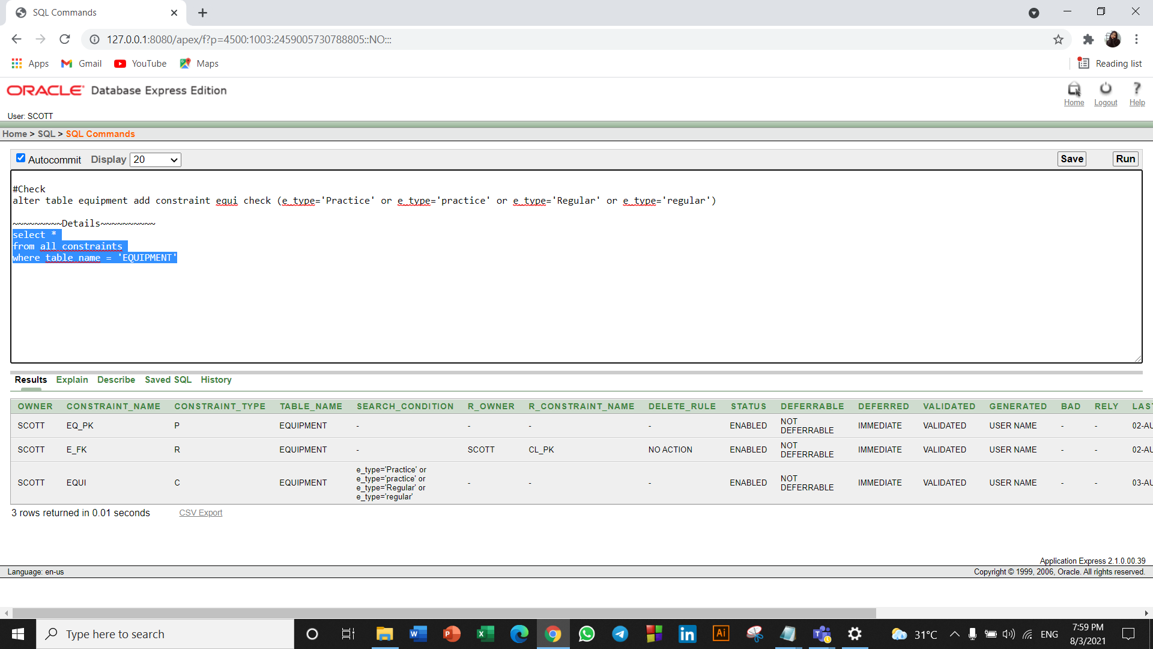

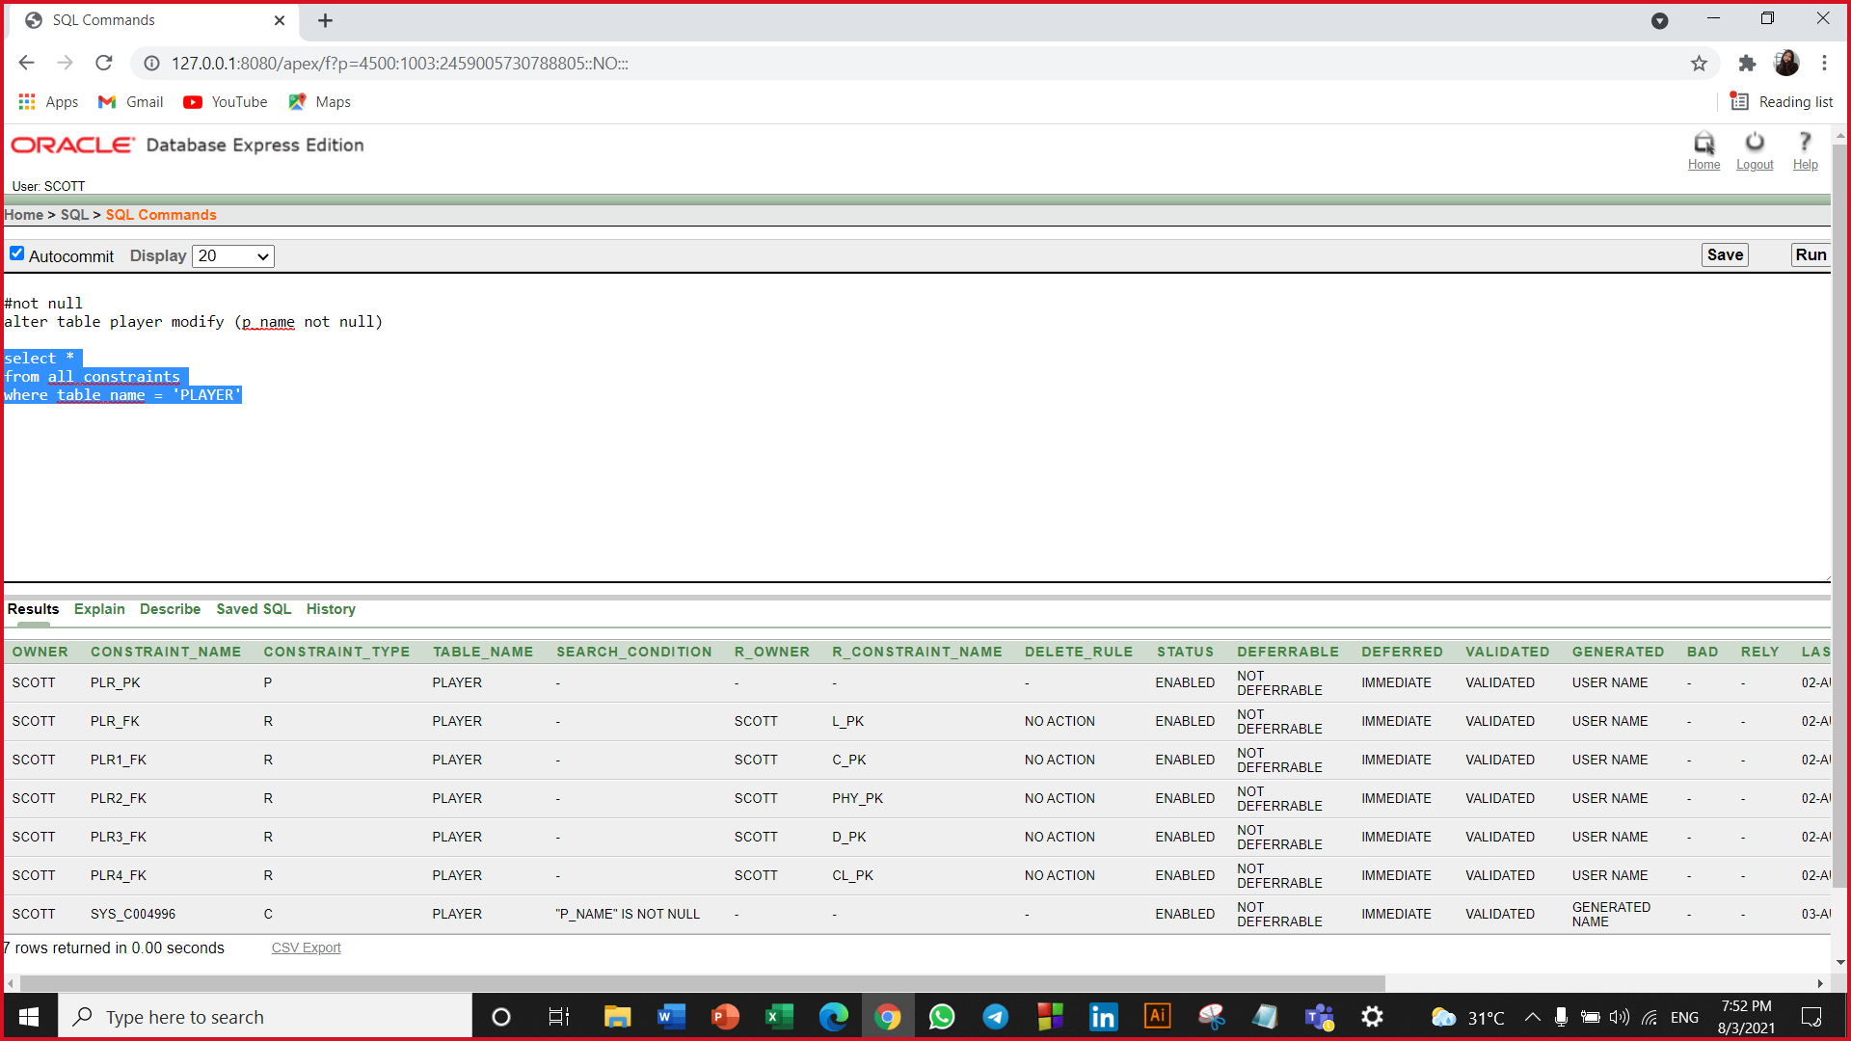

**QUESTIONS:**

**##Sub_Query**

**Q1:** Display the player’s name, player id for all players whose name starts with ‘S’

**Q2:** Display the id, name, and age from player table. Where age is less than 24. Order the query in ascending order by age.

**##Join**

**Q3:** Write a query in SQL to display name & ID for player and doctor.

**Q4:** Write a query in SQL to display the id, name, phone and experience from physician and p_quality.

**##Function**

**Q5:** write a query to display doctor id, name, name length and concate name and id

**Q6:** Display the total equipment from equipment table, where club id is 333.

**Q7:** Write a query to display maximum average age of the players.

**##Sequence**

**Q8:** Alter the sequence increment by 2 & make the sequence cycle & min value is 20 and max value is 110.

**##constraint**

**Q9:** Create and display the phone from physician table is unique.

**##view**

**Q10:** Create a view called Match_details based on the cl_id, m_type and time

from the MATCH table. Change the heading for the TIME to DATE_AND_TIME.